What do you mean by Direct memory access (DMA)? Explain about the working of DMA controller.
Or Explain the working of DMA controller with 8085 microprocessor.
Direct Memory Access (DMA) is the process of directly accessing the memory by I/O devices for the faster data transfer without the involvement of CPU. In other words, we set CPU free so that, it doesn’t have to wait for the slow I/O device to get ready for the data transfer. There is a special device called DMA controller which perform this operation.

Working of DMA controller with 8085 microprocessor
In I/O data transfer, data is transferred, by using microprocessor. The microprocessor will read data from I/O device and then will write data to memory. In this case, there are two operations for single data transfer. If the data is less, then microprocessor will not waste its time; transferring data from I/O to memory or back. But suppose, data is huge, then the transfer rate from I/O to memory or back will slow down because of microprocessor intervention. In such case, to speed up the process of transferring the data, we can think, Can I/O have direct access to memory ?; and the answer is, yes. It can have Direct memory access (DMA), but under Supervision. The device which supervises, data transfer is named as DMA controller. Now let's have diagrammatic representation of the scheme, which depicts microprocessor, DMA controller, memory and I/O device.
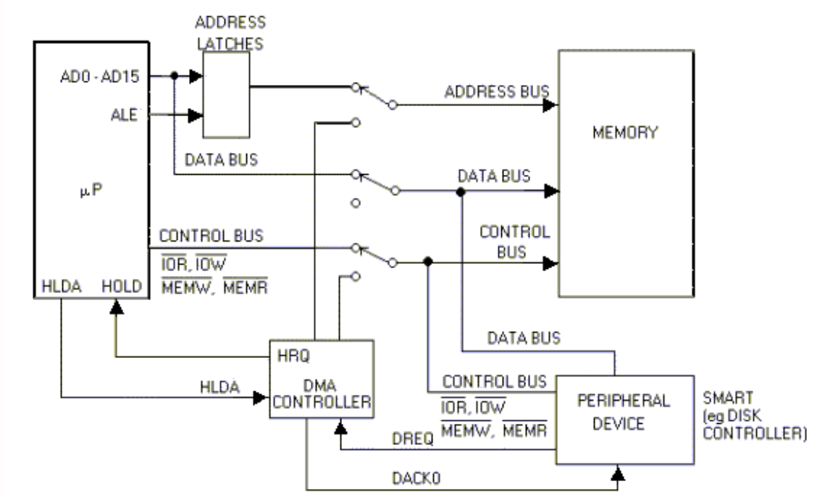
Fig: Block diagram showing showing how DMA controller operates with 8085 microprocessor.

Let's understand the concept clearly.
- Initially, switches S1, S2 and S3 are at upper position.
- No direct access to memory by I/O.
- Microprocessor is MASTER of all three buses; address, data and control.
- Microprocessor treats DMA controller, as I/O device ONLY.
- Using IN/OUT instruction, you can program DMA controller chip, for various
- modes.
- Whenever, peripheral device is ready to transfer data, DIRECTLY to memory, it
will generate REQUEST (DRQ - DMA REQUEST), to DMA controller, asking for
direct access.
- In response to DRQ, DMA controller will activate, HRQ (HOLD request); connected
to HOLD pin of microprocessor. By activating HOLD line, DMA controller request
microprocessor, to HOLD for some time and allow him to become a master of all
three buses.
- Moment HOLD pin is HIGH; microprocessor will complete the present job and also
- activate HLDA (HOLD acknowledge) signal; informing, DMA controller to become
master.
- Microprocessor tristate, all its buses, so total cutoff from memory and I/O device.
- Thus, microprocessor relinquishes the buses and provides control to DMA controller.
- Now DMA controller is master. It will position all three switches to lower position
DMA controller will also generate DACK (DMA acknowledge) signal to peripheral
device; informing that, direct access is allowed.
- Now it will generate address and control signal. Data will flow from memory to I/O
or vice versa.
- After completing data transfer, DMA controller will deactivate HOLD line. It also
positions, switches back to upper position.
- Now microprocessor will regain the control over the three buses.
- Microprocessor will start executing instructions from main program. Till DMA is
inactive or not master of the bus, is referred as DMA IDLE Cycle. When DMA
controller gains the control; it is referred as DMA Active Cycle.
- This is about basics of DMA Now let's study the different methods of transferring
data.

8237 DMA Controller
Features :
8237 is a programmable Direct Memory Access controller
(DMA) housed in a 40-pin package
It has four independent channels with each channel capable of
transferring 64K bytes
It must interface with MPU and a peripheral device
It is an I/O device to MPU
It is a data transfer processor to peripheral device
Many of its signals that are input in the I/O mode become
outputs in the processor mode

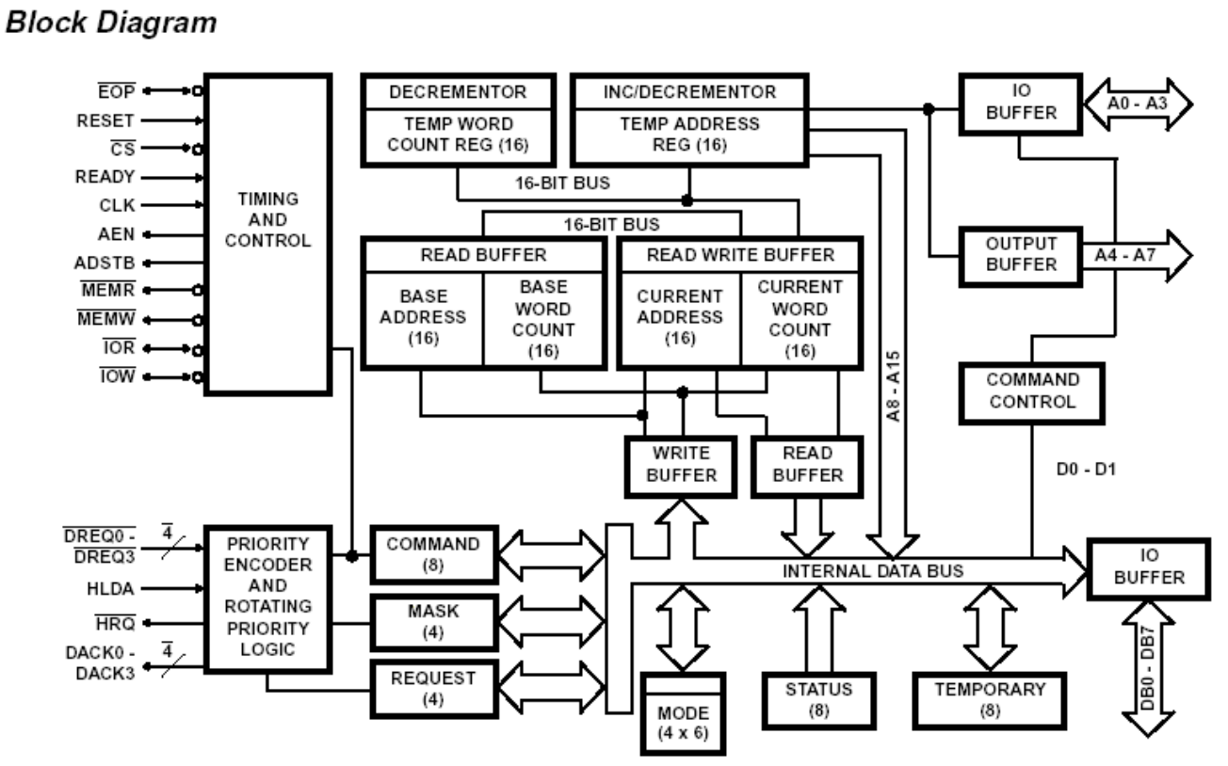
Fig: Block Diagram of 8237 DMA Controller

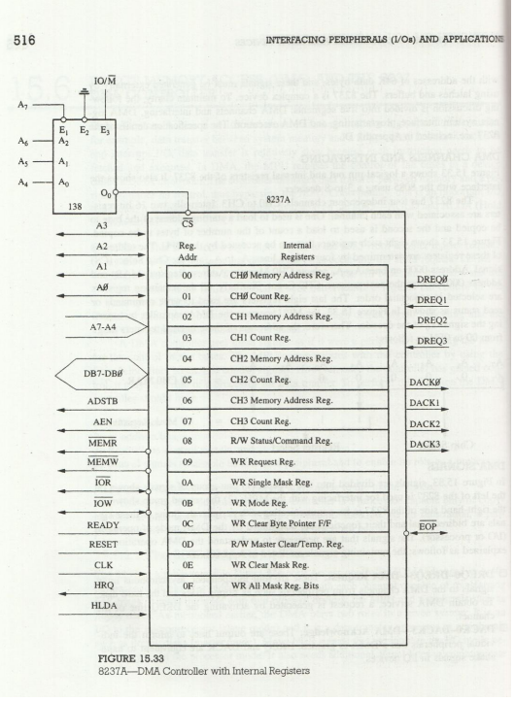

Description:
The block diagram shows a logical pin out and internal registers of the 8237. It also shows the interface with the 8085 using a 3-to-8 decoder
8237 has four independent channels CH0-CH3. Two 16-bit registers are internally associated with each channel
These registers are determined by A3-A0 and the chip select line (CS)
The 8237 signals are divided into two groups:
1) signals on left (used to communicate with MPU)
2) signals on right (used to communicate with peripheral)
Some of these signals are bidirectional and are determined by the DMA mode of operation (I/O or processor mode)
DMA Signals:
To obtain DMA service, a request is generated by activating the DREQ line of the channel
DACK are output lines to inform the individual peripherals that DMA is granted. DREQ and DACK are eqvt to handshake signals in I/O devices
AEN and ADSTB-Address Enable and Address Strobe are used to latch a high-order byte to generate a 16-bit address
After receiving the HRQ (Hold request), the MPU completes the bus cycle in process and issues the HLDA (Hold Acknowledgement) signal
System Interface
When a transfer begins, the DMA places the low-order byte on the address bus and high-order byte on the data bus
Then 8237 asserts AEN (Address Enable) and ADSTB (Address Strobe)
These two signals are used to latch the high-order byte from the data bus and 8237 places the 16-bit address on the system bus.

